Capstone Project Assignment
Full- Stack Application Development & Deployment
Project – Task Flow

1.1 Background
In modern organisations, teams struggle with scattered task tracking, poor project visibility, and fragmented communication. Engineers, designers, QA engineers and project managers often operate across multiple disconnected tools — leading to missed deadlines, duplicated effort, and reduced productivity. There Technologies are used MERN Stack.

1.2 Core Problems Addressed
- Lack of a unified platform to manage tasks, projects, and team members in one place
- No real-time visibility into task progress and project health for stakeholders
- Difficulty tracking individual workload, deadlines, and overdue items
- Absence of structured role-based access for team collaboration (Admin, Manager, Member, Viewer)
- No analytics or reporting to identify bottlenecks and measure team productivity
- Fragmented notification and activity trail, making accountability difficult.

1.3 Solution
Task-Flow is a full-stack, web-based project management application designed to centralise all aspects of team task management into a single, intuitive interface. It provides:
- A Kanban board for visual task organisation and drag-and-drop prioritisation
- Project-level grouping with member assignment and progress tracking
- Role-based access control with four distinct permission tiers
- Analytics dashboards for data-driven decision-making
- Real-time notification system for task assignments and updates
- Secure JWT-based authentication with password reset via email.

2. Project Idea:
Task Flow Application.

3. Frontend Development Tech Stack:
• JavaScript
• React.js
• Tailwind CSS
• Run-command npm run dev
Features:
• Authentication (Login/Signup)
• Main Interface
• API Integration
• Responsive UI (mobile + desktop)
• Error handling
• Pagination
• Component Based Architecture.

4. Backend Development Tech Stack:
• JavaScript
• Node.js
• Express.js
• Run command – nodemon server.js
Feature:
• Restful APIs
• Authentication & Authorization (using JWT)
• Database integration
• Input validation
• Proper Error Handling
• Separate Controller, models, middleware, Routes.

5. Database: NoSQL:
• MongoDB
Features:
• Proper & Flexible Schema Designing
• CRUD Operation
• Separate Schema (Event, User)
• Atlas Based Services (Architecture).

6. Folder Structure:
• Backend Folder Structure.
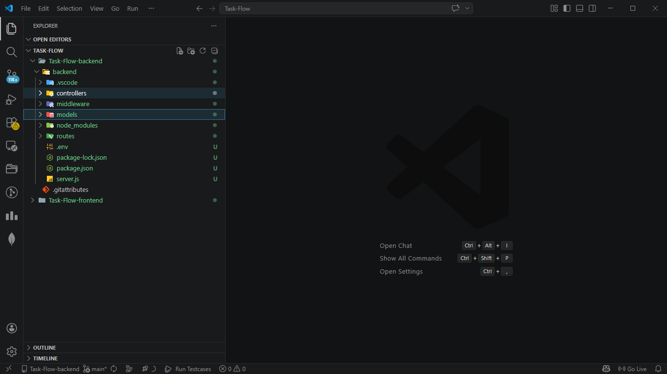

• Frontend Folder Structure.
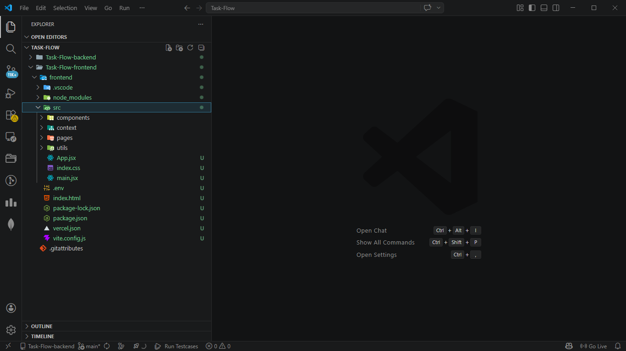

7. Project Feature:
• User Signup
• User Login
• Crud Operation (Events create, read, update, delete)
• Component based architecture
• API-based architecture
• Proper Error handling
• Responsive UI (mobile + desktop friendly)
• Contact feature (user message via our Email)
• Loading States
• Attractive Event Gallery (our recent event memories) Footer bar.

8. Testing:
• API Testing (Postman, Thunder client)
• Unit testing(jest).

10. Dependencies (10 packages):
- Core framework – react, react-dom.
- Routing - react-router-dom.
- HTTP client – axios.
- Charts & analytics - chart.js, react-chartjs-2.
- Drag & drop - @dnd-kit/core, @dnd-kit/sortable, @dnd-kit/utilities.
- Date utilities - date-fns.
- Dev dependencies – vite, @vitejs/plugin-react, @types/react, @types/react-dom.

Install all Dependencies:
npm install react react-dom react-router-dom axios chart.js react-chartjs-2 @dnd-kit/core @dnd-kit/sortable @dnd-kit/utilities date-fns

11.NPM packages & Libraries
Frontend:
• Tailwind CSS – for attractive design
• React-icons – icons like 3 line menu bar close icons
• Axios - for frontend + backend connection
• React-Toastify – for toast notify and backend response
• React-DOM routing in frontend
Backend:
• Axios – for frontend connection
• bcrypt – for password hashing
• CORS – for frontend origin access
• Dotenv- for environment variables
• Express- for run backend server
• Joi – for backend controller Validation
• Jsonwebtoken - for authentication
• Mongoose – for mongodb connection
• Nodemailer- for handling SMTP (simple mail transport protocol).

11.Deployement:
• Git-GitHub URL – Frontend - https://github.com/Suryanshmalviya/task-flow-frontend
Backend - https://github.com/Suryanshmalviya/task-flow-backend
• Vercel Frontend - https://taks-flow.vercel.app/
• Render backend - https://task-flow-arb8.onrender.com
• Live – Video – Video
• Application-Live - https://taks-flow.vercel.app/login

Candidate details:
• Name – Suryansh Malviya
• Mobile – 8602090865
• Email – suryanshmalviya870@gmail.com

THANK YOU

